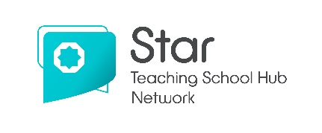
Routes to becoming
a qualified teacher
Achieving Qualified Teacher Status (QTS) is essential in becoming a
qualified teacher. You need QTS to teach in primary, secondary and
special schools in England. This guide outlines what training you need.
In addition to having a degree, you must have GCSE English and Mathematics at grade 4 (C) or above, or an approved equivalent. To apply for a primary programme, you must also have GCSE Science at grade 4 (C) or above, or an approved equivalent. Level 2 Functional Skills is not an equivalent for entry into teaching.
Please note that this is a guide - different training providers may have specific criteria for each route.

I have a degree but no experience in teaching
I don’t have a degree
I have a degree and
I’m an experienced unqualified teacher

1. University degree
3. Postgraduate
teacher training

2. Undergraduate apprenticeship
4. Postgraduate
apprenticeship

5. Assessment-only

QTS = Qualified Teacher

Please see overleaf for more information on each section
1. University degree
Bachelor’s degree
- The most common route if you are wishing to teach a subject in secondary schools.
- Typically, a three-year university course.
- Level 3 qualifications would be required.
- Tuition fees apply – These vary per university (approximately £9,250 per year).
- Funding support is available through Student Finance.
- With a Bachelor’s degree, you would then need to complete a one-year postgraduate course to achieve QTS.
Bachelor’s degree with QTS
- A common route if you are wishing to teach in primary schools.
- Typically, a three or four-year university course that includes QTS.
- Level 3 qualifications would be required.
- Tuition fees apply – These vary per university (approximately £9,250 per year).
- Funding support is available through Student Finance.
- You might also be eligible for bursaries and scholarships (subject-dependant).

2. Undergraduate apprenticeship
Teacher Degree Apprenticeships (TDAs)
- A new route to becoming a qualified teacher.
- A 4-year full-time programme that involves working in a school and earning
a salary, whilst working towards getting a Bachelor’s degree with QTS.
- Level 3 qualifications would be required.
- Fully-funded - No tuition fees and you will also receive a salary.
- You will spend approximately 40% of your time studying for a degree
with a university.

Please see overleaf for information on postgraduate options
3. Postgraduate teacher training
Postgraduate Certificate of Education (PGCE) including QTS
- A one-year programme delivered by a university, a School Centred Initial
Teacher Training provider (SCITT) or a School Direct partnership.
- Tuition fees apply – these are approximately £9,250.
- Funding support is available through Student Finance.
- Bursaries and scholarships are available for certain secondary subjects.

University
- Lecture-based postgraduate course which includes at least two school placements.

School Centred Initial Teacher Training (SCITT)
- A school-based course with regular training delivered by a SCITT.
- The PGCE qualification is delivered by a partner university.

School Direct
- A school-based course with regular training delivered by a partner university
or School Centred Initial Teacher (SCITT) provider.
- Salaried places available where you are paid as an unqualified teacher with the school paying the tuition fees. Most programmes lead to a PGCE qualification (there may be an additional cost to you for this).
- Fee-funded places available. Course fees are usually around £9,250 but funding support is available via Student Finance. For certain subjects, bursaries and scholarships are available up to £31,000. The PGCE qualification is delivered
by a partner university.

4. Postgraduate apprenticeship
PGTA (Postgraduate Teaching Apprenticeship)
- A relatively new route to becoming a qualified teacher.
- A full-time employment-based programme that involves working in a school,
whilst earning a salary.
- Fully-funded - No tuition fees and you will also receive a salary.
- Most programmes lead to a PGCE qualification (there may be an additional
cost to you for this).

5. Assessment-only
Assessment-only route to QTS
- 3 month fast-track route for experienced unqualified teachers that have
sole responsibility for teaching, assessment and planning.
- You must be able to prove you meet the Teachers’ Standards without
needing additional training.
- You will complete a series of assessments over 12 weeks.
- Fees are usually between £1,500 - £4,000 (may be covered through your school).

For more information, please visit:
- getintoteaching.education.gov.uk
- starteachingschoolhubs.org/programmes/train-to-teach

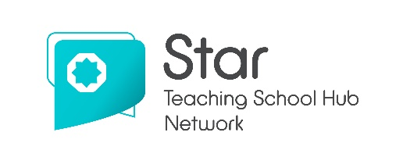

Shadsworth Road, Blackburn BB1 2HT
0330 313 9870 | info@starteachingschoolhubs.org
starteachingschoolhubs.org | @StarTSHubs

